CHAPTER 27 Case Study: Strategic Financial Planning in Long-Term Care Neil R. Dworkin, PhD
BACKGROUND
John Maxwell, CEO of Seabury Nursing Center, a not-for-profit long-term care organization located in suburban Connecticut, had just emerged from a board of directors meeting. He was contemplating the instructions he had received from the board’s executive committee to assess the financial feasibility of adding a home care program to the Center’s array of services.
Seabury’s current services consist of two levels of inpatient care, chronic care, and subacute units, and a senior citizens’ apartment complex financed in part by the Federal Department of Housing and Urban Development. In keeping with its mission, Seabury has a reputation of providing personalized, high-quality, and compassionate care across all levels of its continuum.
The CEO and his executive team agreed to meet the following week to plan the next steps.
FRAMEWORK OF THE BOARD’S MANDATE
At its last retreat, the board made clear that, reimbursement and payment systems notwithstanding, Seabury must establish realistic and achievable financial plans that are consistent with their strategic plans. Accordingly, three points relative to integrating strategic planning and financial planning should hold sway:
1. Both are the primary responsibility of the board
2. Strategic planning should precede financial planning
3. The board should play an active role in the financial planning process
Ultimately, every important investment decision involves three general principles:
1. Does it make sense financially?
2. Does it make sense operationally?
3. Does it make sense politically?
The board’s interest in a possible home initiative was guided by these stipulations, particularly as they relate to Seabury’s growth rate in assets and profitability objectives. As a result of the financial downturn, the organization is experiencing declining inpatient volumes, a deteriorating payer mix, and a higher cost of capital, all of which have the potential to weaken its liquidity position.
Taking the strategic service line path to a home care program would be less capital intensive and should appeal broadly to the significant baby boomer population residing in its service area, whose preference would undoubtedly be to be treated in their homes.
INDUSTRY PROFILE
When John Maxwell convened his executive team the following week, he had already decided to present an overview of the home health industry as gleaned by Seabury’s Planning Department. He prefaced his comments by drawing on recent research by the federal Agency for Healthcare Research and Quality that detailed why home health care in the 21st century is different from that which has existed in the past. He cited four reasons:
1. We’re living longer and more of us want to “age in place” with dignity.
2. We have more chronic, complex conditions.
3. We’re leaving the hospital earlier and thus need more intensive care.
4. Sophisticated medical technology has moved into our homes. Devices that were used only in medical offices are now in our living rooms and bedrooms. For example, home caregivers regularly manage dialysis treatments, infuse strong medications via central lines, and use computer-based equipment to monitor the health of loved ones.¹
The CEO presented a profile of national home care data as compiled by the National Association for Home Care and Hospice as follows:
• Approximately 12 million people in the United States require some form of home health care.
• More than 33,000 home healthcare providers exist today.
• Almost two-thirds (63.8%) of home healthcare recipients are women.
• More than two-thirds (69.1%) of home healthcare recipients are over age 65.
• Conditions requiring home health care most frequently include diabetes, heart failure, chronic ulcer of the skin, osteoarthritis, and hypertension.
• Medicare is the largest single payer of home care services. In 2009, Medicare spending was approximately 41% of the total home healthcare and hospice expenditure.²
According to the U.S. Census Bureau, he continued, in 2010 Connecticut’s population was 3,574,097 of which 14.4% were age 65 or older.³ A Visiting Nurse Association (VNA) analysis of revenue by payer source in the state indicated that 60% of revenue was derived from Medicare.⁴
FEASIBILITY DETERMINATION
The CEO went on to explain that the feasibility determination would be based on initially setting the home care program’s capacity at 50 clients because that was the minimum required for Certificate-of-Need (CON) approval in Connecticut. He distributed a model developed by healthcare finance expert William O. Cleverly (Figure 27–1), which presents the logic behind the integration of strategic and financial planning.
In essence, he said, financial planning is influenced by the definition of programs and services in consort with the mission and goals. The next step entails financial feasibility of the proposed homecare program. Among the components that should be considered in determining financial feasibility are the following:
• The configuration and cost of staff
• The prevailing Medicare and Medicaid reimbursement rates
Figure 27–1 Integration of Strategic and Financial Planning.
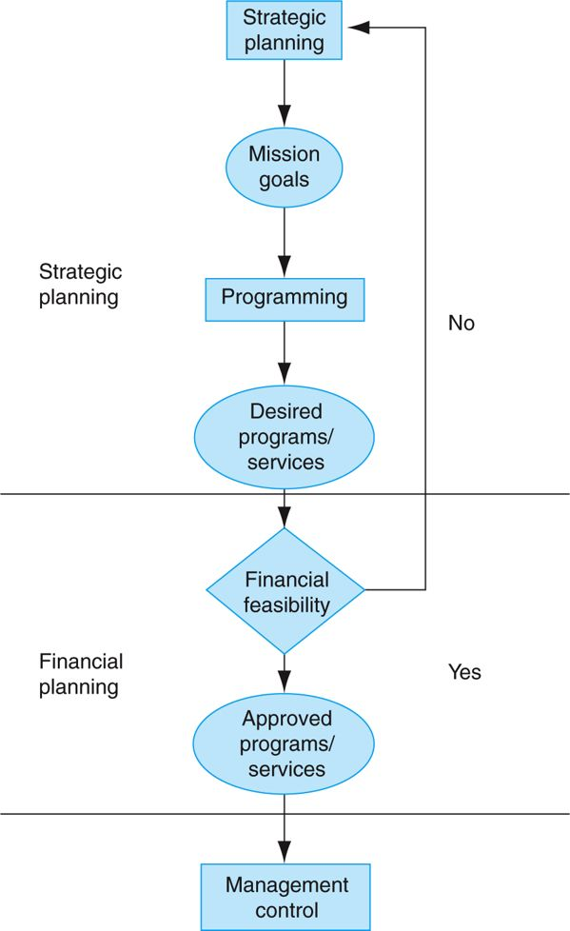
Reproduced from W.O. Cleverley, Essentials of Health Care Finance, 7th ed. (Sudbury, MA: Jones & Bartlett), 289.
• A projection of visit frequency by provider category based on the most prevalent clinical conditions
• The physical location of the program and its attendant costs (e.g., rent, new construction)
• A projection of cash flows
Direct care staff associated with the home care program includes:
• Medical Social Worker (MSW)
• Physical Therapist (PT)
• Home Health Aide (HHA)
• Registered Nurse (RN)
• Registered Dietitian (RD)
Maxwell indicated that it would be useful to create a scenario depicting a home health visit abstract incorporating prevailing Medicare and Medicaid reimbursement rates for a 70-year-old male with heart failure and no comorbidities in order to gain traction and project potential cash flow. As previously noted, heart failure is a condition frequently requiring home healthcare services. Productivity in the home is typically based on the average number of visits per day by provider category. The visit scenario is depicted in Table 27–1.
Table 27–1 A Home Health Visit Scenario
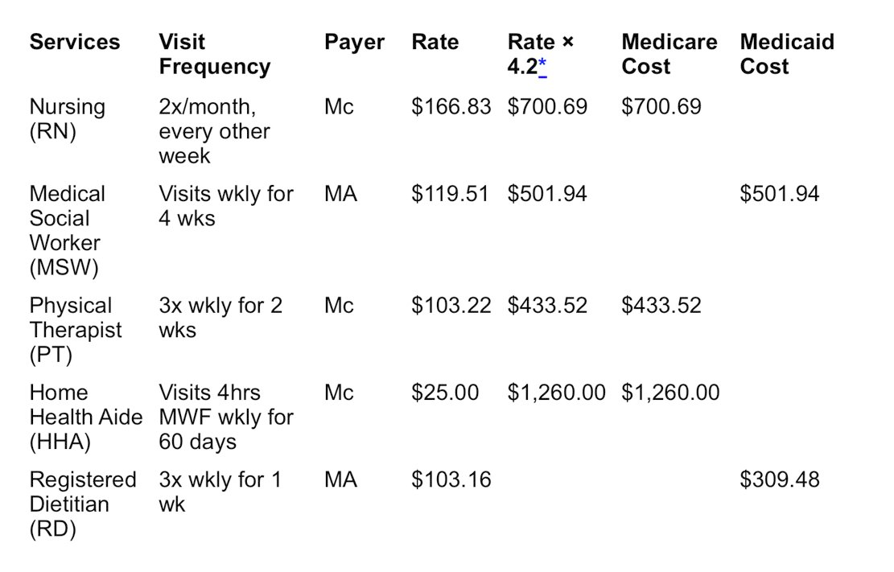
Mc = Medicare
MA = Medicaid
* 4.2 = The state′s formula for the #wks/per month
Total monthly Medicaid budget = $826.95
Total monthly Medicare budget = $2,394.21
Figure 27–2 Seabury Nursing Center’s Home Healthcare-Related Organization Chart.
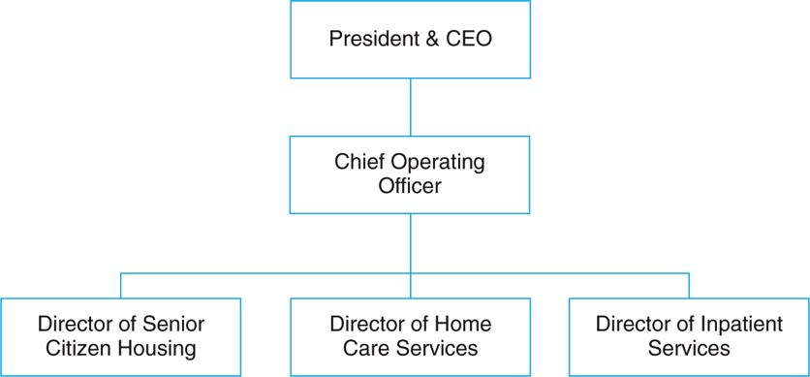
Once the board decides to move ahead with the home care program and it is approved by the state, implementation and ongoing operations becomes a management control issue (see the Cleverly model in Figure 27–1). The CEO refers to a proposed table of organization as illustrated in Figure 27–2.
Given the paucity of other home care programs in its service area, Maxwell knows that Seabury is likely to be accorded a green light.
As he and his team reflect on this, the looming question will be where will the clients come from? He knows that likely referral sources will include Seabury’s subacute inpatient population and residents from its senior citizens’ apartment complex who are
“aging in place.” Other likely sources will be recently discharged patients from the region’s two community hospitals, both bereft of home care programs. A premium will be placed on effective case management, and direct marketing to the community will also be necessary.
NOTES
1. U.S. Department of Health and Human Services, “Human Factors Challenges in Home Health Care,” Research Activities, no. 376 (December 2011).
2. National Association for Home Care and Hospice, Basic Statistics about Home Care (Updated 2010).
3. Department of Commerce, U.S. Census Bureau, 2010 Demographic Profile.
4. Visiting Nurse Association, VNA Healthcare Annual Report (Hartford, CT: Hartford Healthcare, 2012).
(Baker 387)
Baker, Judith J. Health Care Finance, 4th Edition. Jones & Bartlett Learning, 08/2013. VitalBook file.
The citation provided is a guideline. Please check each citation for accuracy before use.

